**AIDA Strategy For Yippee Noodles**

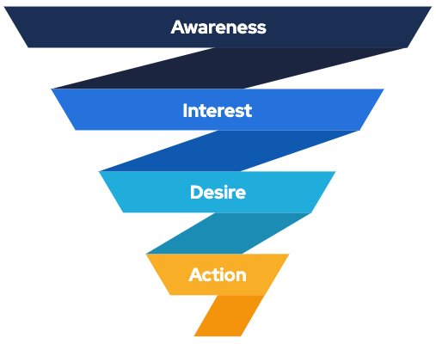

# Attention: B2C

* **Platforms: Google Ads, Facebook Ads**
* **Demographics: Male and Female of Age 12 to 25**
* **Interest: Buying Noodles**
* **Content: Video Ads, Display Ads**

# Interests: B2C

* **Platforms: Instagram, Facebook, YouTube**
* **Demographics: Male and Female of Age 12 to 25**
* **Interest: Buying Noodles**
* **Content: Video Ads, Text and Image, Sponsored Post**

# Desire: B2B and B2C

* **Platforms: Instagram, Facebook, LinkedIn, YouTube**
* **Demographics: Male and Female of Age 12 to 50**
* **Interest: Buying Noodles**
* **Content: Video Ads, Display Ads, Sponsored Post, Text with images**

# Action: B2C and B2B

* **Platforms: Amazon, Flipkart**
* **Demographics: Male and Female of Age 15 to 50**
* **Interest: Buying Noodles**
* **Content: Video, Text with images**